KNOW YOUR WATER & SEWER
  - facts about the POMPTON LAKES M.U.A
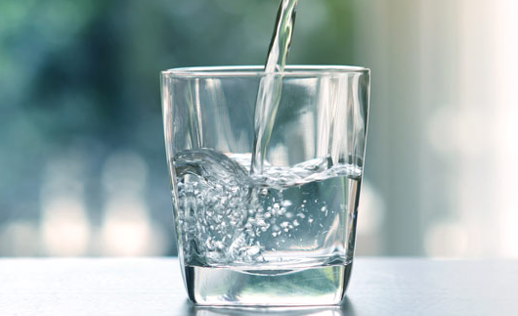
Taste & Treatment  Our water source is supplied by three wells with 30 miles of distribution mains, a 1-million-gallon water storage tank and a 50,000-gallon standpipe.  We make every effort to deliver uninterrupted service to our customers.  Our water is treated with chlorine as a precaution against bacteria.  Our water is monitored for many kinds of substances on a strict sampling schedule.  The water we deliver must meet specific health standards set by the NJ Department of Environmental Protection & The Environmental Protection Agency.  Our water has won the Best Tasting Water in NJ by the NJ Water Association for 4 years. | Billing Quarters  1st Quarter January Bill:  Due Date in February  2nd Quarter April Bill:  Due Date in May  3rd Quarter July Bill:  Due Date in August  4th Quarter October Bill:  Due Date in November  Online payments can be made on our website: www.plbmua.org |  | Common Water Concerns  Discolored/Smelly water – Mineral sediment in pipes. May be aesthetically displeasing, but not a health risk. Rotten egg odor caused by non-toxic pockets of hydrogen-sulfide. Run cold water for 15-20 min. until it runs clear.  Cloudy water – air bubbles or calcium in water. When left sitting, bubbles rise to surface & dissipate. Calcium carbonate precipitate is safe to drink & for cooking.  Hardness – refers to concentration of nontoxic minerals (calcium & magnesium). A characteristic of ground water. Has no adverse effect on health. According to the National Academy of Sciences it may contribute to a healthy diet.
Meter Care  Meters are found inside the house typically in a closet, crawl space or basement.  To avoid freezing, cracking and/or flooding keep the temperature in your home at or above 50 degrees Fahrenheit.  This temperature will also protect the integrity of your other household plumbing. |  | WHEN TO CALL A PLUMBER OR THE M.U.A  Call the Plumber for:  - Leaking valves before & after meter/within the home  - Running toilet  - Low water pressure caused by pressure regulators/reducers or filtration systems issues  - Normal residential water pressure is between 80 to 100 psi  - Due to the towns high water pressure, water pressure regulators/reducers are recommended  Call M.U.A for:  - Water Meter issues (see meter care)  - Disruption of water/sewer and/or possible sewer mainline blockages

